Lab No.8

Object: Computer Printing with multiple options
Description : Printers are Output devices used to prepare permanent Output devices on paper. They are well known Output devices which are used and utilized for printing output on paper and are called as HARDCOPY. The Output produced from them is almost permanent. User can produce and create output such as text or pictures and images. The output produced on display devices such as monitor are called as SOFTCOPY.
Hardcopy printouts can be acquired on paper with particular sizes like A4,Legal,Letter or custom sizes.A3 is used in bigger sizes printouts. The orientation of the printouts can be determined by the presence of the printout i.e. vertically or horizontally. A vertical orientation is known to Portrait and the horizontal is known as Landscape orientation.
A Portrait view is a printout where the printout is taller than the width of paper. A Printout which is wide and taller is called as Landscape orientation Books, letters, novels are portrait orientation whereas Excel sheets use landscape view. They come in different sizes, speed, and capabilities the speed of various printers are measured in CPS- Character Per Second, LPS-Lines Per Second, PPS-Pages Per Seconds.
Printers are connected to Personal computer with the utilization of USB Printer cable for speedier execution speed.
The printout can be received on different materials such as paper, plastic sheets, clothes like T-Shirts. Special printers have been developed for a specific task such as to print photocopy of images photo printers are used.
Printers can be divided into two main categories :
Impact Printers : In this hammers or pins strike against a ribbon and paper to print the text. This mechanism is known as electro-mechanical mechanism. The prime examples of impact printers are Dot-matrix, Daisywheel, Drum, character, or line printers. They are fairly similar like the old typewriters used earlier. The printouts were acquired such as graphics or content on a piece of paper by striking a component against an inked ribbon that physically and straightforwardly contacts the paper.
They create noise when striking components like head and ribbon strikes against the paper they are extensively used in small organizations, factories and are used where large number of printout needs to be obtained. They are cheap, slow, and loud. They create low-quality outputs hence they are widely used in those sectors where quality does not matter, where users need quantity.

They are of two types.
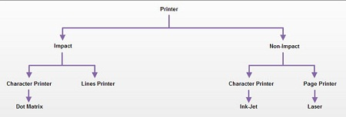
Character Printer : It prints only one character at a time. It has relatively slower speed. Eg. Of them are Dot matrix printers.
Dot Matrix Printer : It prints characters as combination of dots. Dot matrix printers are the most popular among serial printers. These have a matrix of pins on the print head of the printer which form the character. The computer memory sends one character at a time to be printed by the printer. There is a carbon between the pins & the paper. The words get printed on the paper when the pin strikes the carbon. There are generally 24 pins.
Laser Printer is a type of printer that utilizes a laser beam to produce an image on a drum. The light of the laser alters the electrical charge on the drum wherever it hits. The drum is then rolled through a reservoir of toner, which is picked up by the charged portions of the drum. Finally, the toner is transferred to the paper through a combination of heat and pressure.
This is also the way copy machines work. Because an entire page is transmitted to a drum before the toner is applied, laser printers are sometimes called page printers. There are two other types of page printers that fall under the category of laser printers even though they do not use lasers at all. One uses an array of LEDs to expose the drum and the other uses LCDs. Once the drum is charged, however, they both operate like a real laser printer. One of the chief characteristics of laser printers is their resolution – how many dots per inch (dpi) they lay down.

The available resolutions range from 300 dpi at the low end to 1,200 dpi at the high end. In addition to text, laser printers are very adept at printing graphics, so you need significant amounts of memory in the printer to print high-resolution graphics. To print a full-page graphic at 300 dpi, for example, you need at least 1 MB (megabyte) of printer RAM. For a 600 dpi graphic, you need at least 4 MB RAM.
Because laser printers are non-impact printers, they are much quieter than dot matrix or daisy-wheel printers. They are also relatively fast, although not as fast as some dot-matrix or daisy-wheel printers. The speed of laser printers ranges from about 4 to 20 pages of text per minute (ppm). A typical rate of 6ppm is equivalent to about 40 characters per second (cps).
Non-Impact Printers : There printers use non-Impact technology such as ink-jet or laser technology. There printers provide better quality of O/P at higher speed. They does not touch the paper when making lines and images. Some of them use shower ink and others use warm , heat and pressure for producing lines and graphics. They do not make any noise as they do not physically touch the paper. They produce better quality printouts. They are cheap as compared to impact printers. They are much speedier than impact. Their speed is measured in PPM (Pages Per Minute)
The prime examples of non-impact printers are ::
- Laser
- Inkjet
- Thermal
- Photo
- Plotters etc
These printers are of two types :
Ink-Jet Printer : It prints characters by spraying patterns of ink on the paper from a nozzle or jet. It prints from nozzles having very fine holes, from which a specially made ink is pumped out to create various letters and shapes. The ink comes out of the nozzle in a form of vapors. After passing through a reflecting plate, it forms the desired letter/shape at the desired place.The famous Manufacturer of printers are Epson, HP, Canon
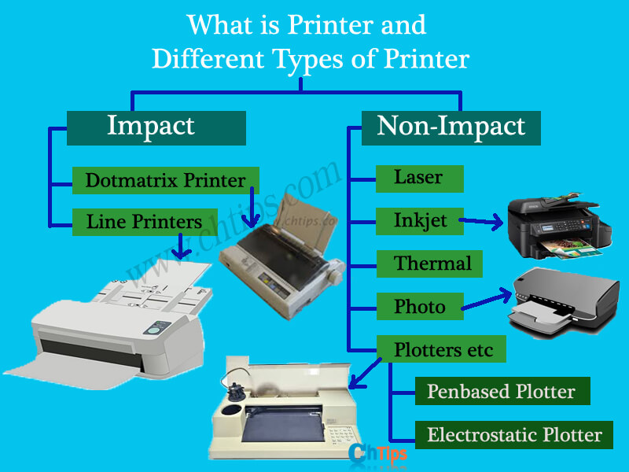
Printers and Different Types
LASER PRINTERS ::
They are have the potential of converting computer output into print page by page. They are high speed, high quality, and superb nonimpact printers and enable user's to printouts in A4 and Legal sizes.
There is a removable plate where the paper is physically embedded for printouts. They can print black, white, or color prints and can print black and color prints in high resolution. They are significantly faster compared to inkjet printers.
They are used in large business houses where the user normally requires quality and speed. When the user sends a command for printout the whole page is stored in a memory of the printer. which is commonly called as printer memory. The memory which is used to store the entire documents varies from printer to printer.
For instance some of them can save or store documents up to 1 GB on the other hand some can save up to 160 GB of data while the printing process is to be executed. For more storage capacity Hard disk are installed in printers.
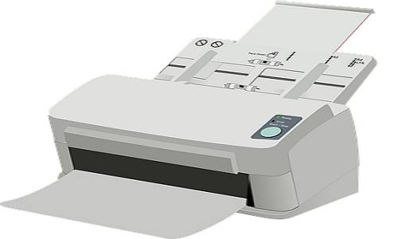
Laser Printer
They save the entire document before printing if it fails to saves or the capacity of the document is larger than the printer memory it usually throws an error message or the process of the printout is canceled due to low memory.
Their Speed is faster when the memory of the printer is capable of storing the processed data or images given for printouts. It drastically decreases when found low memory. They have pre-installed software in these types of printers. They are excellent, fast and produces high-quality printouts. They are very expensive when compared to a dot matrix or inkjet printers.
INKJET PRINTERS ::
This is a type of non-impact printer. They utilize a spout to splash ink on the paper there are a number of small nozzles which splashes ink on the paper in the proper format to create an image and are used in the home or small offices where black white and color printouts are to be produced.
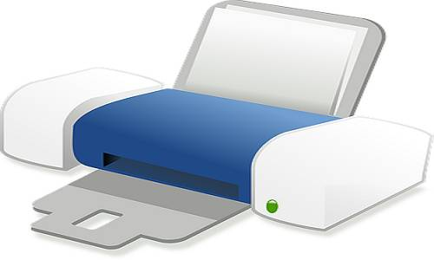
Inkjet Printer
Nowadays printouts can be produced on a variety of objects such as Envelop, T-shirts, visiting cards, invitation cards, etc. The quality or the resolution is measured in DPI higher the DPI better the quality of the printer. They usually spray series of ink dot on paper where the dot is a drop of ink..
The Ink cartridges can be removed or replaced once used or when the ink is found to be empty .many users try to refill the cartridges. There are mainly two cartridges one for black color and another for several colors which are used while printing and these cartridges are denoted by an alphanumeric number when users find to change or to replace just have to mention the number to computer shopkeeper to find the exact and same cartridges to be fit in the printer.
PHOTO PRINTERS ::
They are commonly used for printing photo and images in high quality and are used by professionals where they need to print graphics related images or pictures. They are made up of inkjet technology and have a build-in card slot where users can just unplug the memory card from the camera and directly attached to the printer where they can easily manipulate the images or pictures before final printout.
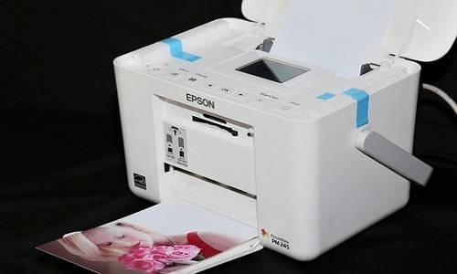
Photo Printer
Many of them have a display screen attached where user can graphically see the input images directly on to the printers for further process.
THERMAL PRINTERS:
They can be seen anywhere railways reservation, restaurants, ATM, credit card swipe, malls everywhere. They produce images by pushing electrically heat pins against heat-sensitive papers and are low in cost as they produce the low quality of images and the images get destroyed as the time passes.
PLOTTERS: ::
Plotters are used for graphical outputs on paper. They are used to print graphs, designs, and drawing on papers instead of alphanumeric characters. Plotters are very expensive and are used mainly by Engineers, Architectures, and designer for printing their drawing , designs, sketch on papers.
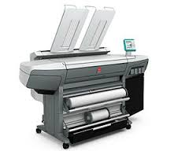
There are mainly two types of plotters::
- Penbased Plotter
- Electrostatic Plotter

Different Types Of Printing Methods:
There are many different types of printing methods available and they're continuing to evolve. Each type is suited to a different need, meaning that businesses can choose a printing technique that best highlights their products or service. So what are the different types of printing and how do they vary from each other?
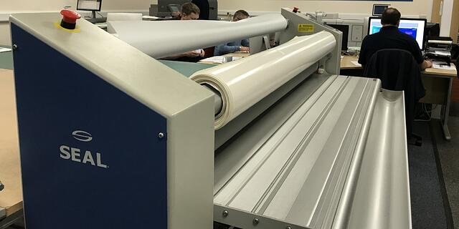
Printing is something that's been around since before 220AD. The oldest known printing technique is known as woodcut and involves carving an image onto a wooden surface.
Printing has evolved a lot since then - instead of manual wood carving, you can choose from a wide range of technologically advanced methods. Here are seven of the most well-known and commonly used types:
- Offset Lithography
- Flexography
- Digital Printing
- Large Format
- Screen Printing
- 3D Printing
- LED UV

Offset Lithography
Often used for:
- Rough-surfaced media e.g. wood, canvas and cloth
- Versatile method so can also be used for books, paper, stationery and more
Also known as offset printing or litho, offset lithography is a very popular method of mass-production printing. It involves printing plates, usually made from aluminium, which each hold an image of the content that needs to be printed.
These plates are then transferred (offset) onto rollers or rubber blankets before going onto the print media, which can be any type of paper you want. The print media doesn't come into contact with the metal plates, which extends the life of the plates. As well as this, the flexible material of the rollers or rubber blankets means offset lithography can be used on any media with rough surfaces.
Offset lithography is great at producing consistently high quality images and can be used for small or high volume print jobs. It's also a versatile choice as it can print on any flat surface, regardless of whether it's smooth like paper or rough like canvas.

Flexography
Often used for:
- Packaging and labels
- Anything with continuous patterns e.g. wallpaper and gift wrap
Flexographic printing is the modern version of letterpress printing and is commonly used for printing on uneven surfaces. This style of printing uses quick-drying, semi-liquid inks and can be used for high volume jobs.
Flexible photopolymer printing plates wrapped around rotating cylinders on a web press are used. These inked plates have a slightly raised image of the content on them and are rotated at high speeds to transfer the image onto the print media.

Flexography is a popular choice for its high press speeds, suitability for long runs and ability to print on a huge range of media including plastic, cellophane and metallic film.

Digital Printing
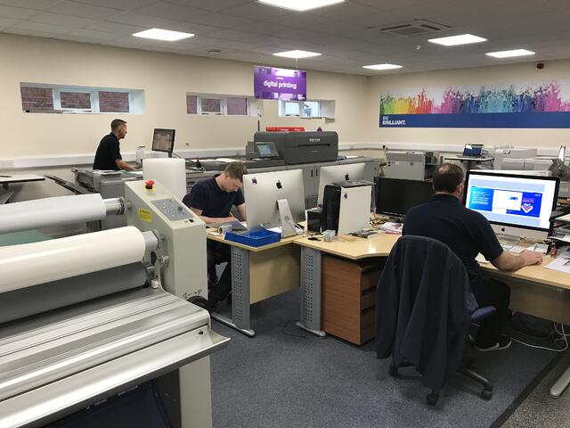Our digital printing studio
Often used for:
- Posters and signage
- Labels, newsletters, menus and letters
Digital printing is a modern method that covers a variety of different techniques including inkjet printing and laser. In digital printing, images are sent directly to the printer using digital files such as PDFs. This eliminates the need for a printing plate, which is used in other types of printing such as lithography, and can save time and money (unless you're printing in larger numbers).
Digital printing allows for quick turnaround and allows businesses to print on demand. It's also great for small run jobs - requests can be made for as little as one print. If you choose digital printing for the right job, it can make for a cost-effective method that still produces high quality prints similar to that of the other, bigger-scale options.

Large Format
Often used for:
- Large signage e.g. billboards, posters, vinyl banners
- Wallpaper and murals
- Floor graphics
- Laminating
As the name might suggest, large format printing exists to produce maximum print roll width. Perfect for traditional advertising mediums and businesses who are looking to make a huge impact on their customers, this printing method gifts you with a much bigger area to work on, as opposed to the other methods such as digital printing.
Rather than printing onto individual sheets, large format printing uses rolls of prints that are fed incrementally to produce one large sheet.
For large print media such as building wraps, billboards, banners and murals, large format printing is the best option. The other printing methods will not be able to produce as large a material. Most businesses choose large format media to produce flat items which can be hung on a wall, but they can also be folded or made to stand freely.

Screen Printing
Often used for:
- Printing logos and graphics onto clothes
- Fabric banners
- Posters
Screen printing is a printing technique where fine material or mesh is used to transfer an image onto another material. The mesh is stretched out so it creates a screen and ink is pressed against it in order to successfully print the image. Popularly used to print graphics onto clothes and other pieces of fabric, screen printing can also be used for paper and metal.
There's a lot of setting up required with screen printing, so it's best used for printing repeat items in bulk. It's not very cost-effective for small number orders. But if you need a lot of the same image, it's a highly cost-effective method of printing.

3D Printing
Often used for:
- Promotion and marketing freebies
- Novelty items
- Display items
- Toy figurines
Since the 1980s, 3D printing has allowed us to print three-dimensional objects, which can be a great way to make an impact on your audience. The desired objects of various shapes and sizes are created using digital model data from 3D models or electronic sources such as an Additive Manufacturing file (AMF). Additive compound mixtures are then fused together to produce this 3D object.
3D printers have continued to get more and more sophisticated. Today, even items with interior moving parts can be printed. After the details have been worked out on a computer programme such as CAD, miniscule layers are printed on top of each other using a special plastic substance.

LED UV
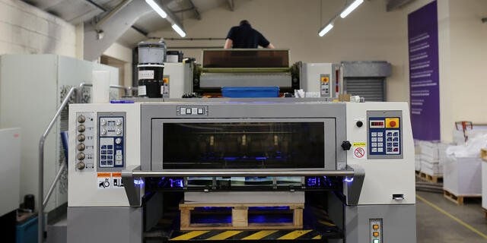
Often used for:
- Newsletters, posters and leaflets
- Magazines, catalogues, brochures and prospectuses
- Stationery
LED UV printing is a method that's becoming increasingly popular among businesses due to its extremely high quality prints and quick turnaround times.
It's a form of digital printing that uses UV (ultraviolet) lights to dry the ink as it's being printed. The drying process, also known as UV curing, is unique and sets it apart from the other printing methods because it's instantaneous and prevents the ink from sinking into the materials.
The results? You no longer have to wait for the ink to dry, which saves time and the colours come out looking much sharper and clearer.
LED UV is eco-friendly as it uses less power than traditional print machines and unlike many of the other methods, it's not limited to the type of stock (printing materials) or to certain print jobs.
Its versatility means it's ideal for a wide range of projects including brochures, catalogues, prospectuses and posters. Because of its ability to instantly dry ink and produce bright, vivid colours, it can turn an ordinary product into a luxury, high quality product that is attention grabbing.
Find Out More About Printing Techniques
There are many different printing methods available - some are suited to different tasks while others are more versatile and can work for a range of requirements. In this post, we've outlined five of the most popular printing methods and what they're best for, but for even more clarity on the topic, download our free eBook on printing techniques.
Exercise
- Explain impact printers
- Explain non impact printers
- Differentiate laser and dot matrix printer

