LAB NO.6
Microsoft PowerPoint for Presentation, slideshow and animations
OBJECTIVE:
- Creating and Editing a Presentation with Pictures
• Select and change a document theme and variant
• Create a title slide and a text slide with a multilevel bulleted list
• Add new slides and change slide layouts
• Insert pictures into slides with and without content placeholders
• Move and resize pictures
• Change font size and color
• Bold and italicize text
• Duplicate a slide
• Arrange slides
• Select slide transitions

THEORY:
In this module, you will learn how to perform basic tasks using PowerPoint. The following roadmap identifies general activities you will perform as you progress through this module:
1. INSERT the four PRESENTATION SLIDES, using various layouts.
2. ENTER the TEXT for the slides.
3. FORMAT the TEXT on each slide.
4. INSERT GRAPHICAL ELEMENTS, including pictures.
5. SIZE AND POSITION the graphical elements.
6. ENHANCE the SLIDE SHOW by adding a closing slide and transition.
7. DISPLAY the SLIDES.

Choosing a Document Theme and Variant
You easily can give the slides in a presentation a professional and integrated appearance by using a theme. A document theme is a specific design with coordinating colors, fonts, and special effects such as shadows and reflections. Several themes are available when you run PowerPoint, each with a specific name. Using one of the formatted themes makes creating a professional-looking presentation easier and quicker than using the Blank Presentation template, where you would need to make all design decisions.

Each theme has a set of four alternate designs, called variants. Each variant has the same overall composition, but the colors, fonts, and design elements differ. Once you select a theme, you then can select a variation that best fits your overall design needs. If you later decide that another theme or variant would better fit the presentation’s general theme, you can change these elements while you are developing slides.

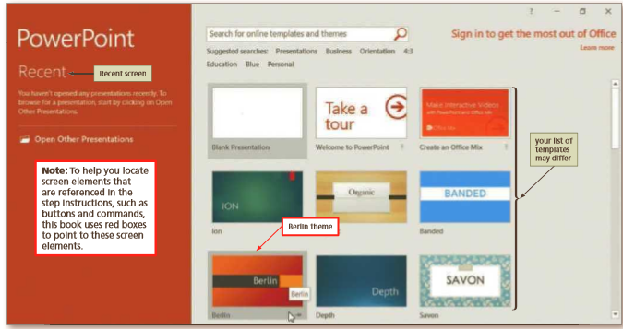

Fig 6-1

Creating a Title Slide
When you open a new presentation, the default Title Slide layout appears. The purpose of this layout is to introduce the presentation to the audience. PowerPoint includes other standard layouts for each of the themes. The slide layouts are set up in landscape orientation, where the slide width is greater than its height. In landscape orientation, the slide size is preset to 10 inches wide and 7.5 inches high when printed on a standard sheet of paper measuring 11 inches wide and 8.5 inches high. Placeholders are boxes with dotted or hatch-marked borders that are displayed when you create a new slide. Most layouts have both a title text placeholder and at least one content placeholder. Depending on the particular slide layout selected, title and subtitle placeholders are displayed for the slide title and subtitle; a content text placeholder is displayed for text, art, or a table, chart, picture, graphic, or movie. The title slide has two text placeholders where you can type the main heading, or title, of a new slide and the subtitle. With the exception of the Blank slide layout, PowerPoint assumes every new slide has a title. To make creating a presentation easier, any text you type after a new slide appears becomes title text in the title text placeholder. The following steps create the title slide for this presentation.

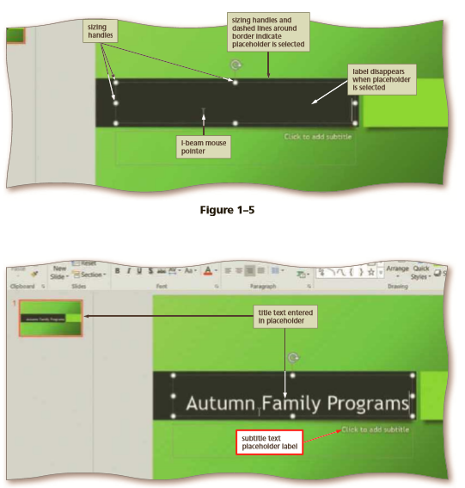Fig 6-2

Adding a New Slide to a Presentation
With the text for the title slide for the presentation created, the next step is to add the first text slide immediately after the title slide. Usually, when you create a presentation, you add slides with text, pictures, graphics, or charts. Some placeholders allow you to double-click the placeholder and then access other objects, such as videos, charts, diagrams, and organization charts. You can change the layout for a slide at any time during the creation of a presentation.

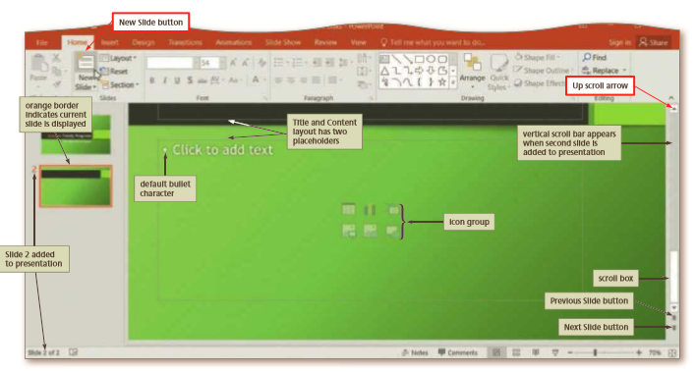
Fig 6-3

Inserting Pictures into Slides
Adding pictures can help increase the visual and audio appeal of many slides. These images may include photographs, illustrations, and other artwork. If you have a Microsoft account, you can add pictures from websites, including Flickr and OneDrive. You can add pictures to your presentation in two ways. One way is by selecting one of the slide layouts that includes a content placeholder with a Pictures button. A second method is by clicking the Pictures button in the Images area on the Insert tab. Clicking the Pictures button opens the Insert Picture dialog box. The Insert Picture dialog box allows you to search for picture files that are stored on your computer or a storage box allows you to search for picture files that are stored on your computer or a storage box device. Contact your instructor if you need the pictures used in the following steps.

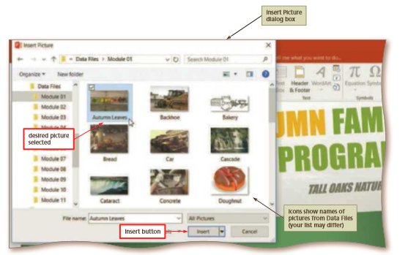
Fig 6-4
Resizing Photos and Illustrations
Sometimes it is necessary to change the size of pictures and illustrations. Resizing includes enlarging or reducing the size of a graphic. You can resize these images using a variety of techniques. One method involves changing the size of a picture by specifying exact dimensions in a dialog box. Another method involves sliding or dragging one of the graphic’s sizing handles to the desired location. A selected graphic appears surrounded by a selection rectangle, which has small circles, called sizing handles or move handles, at each corner and middle location.

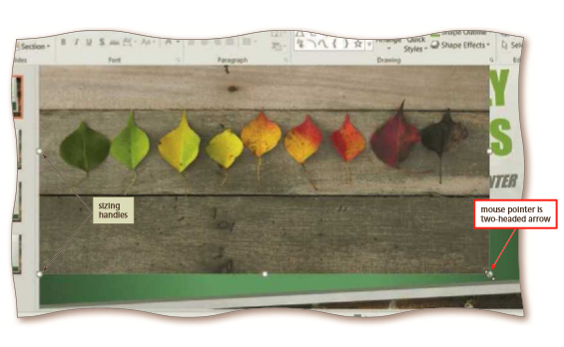
Fig 6-5
Bold and italicize text
Bold characters display somewhat thicker and darker than those that display in a regular font style. Clicking the Bold button on the mini toolbar is an efficient method of bolding text. To add more emphasis to the fact that the body needs nature for cooling purposes, you want to bold the words, every Saturday. The following step bolds this text.
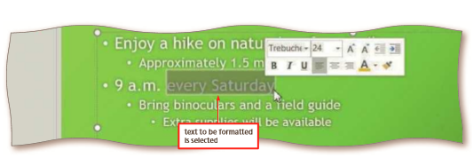
Fig 6-6

Duplicate a slide
When two slides contain similar information and have the same format, duplicating one slide and then making minor modifications to the new slide saves time and increases consistency. Slide 5 will have the same layout and design as Slide 1. The most expedient method of creating this slide is to copy Slide 1 and then make minor modifications to the new slide. The following steps duplicate the title slide.
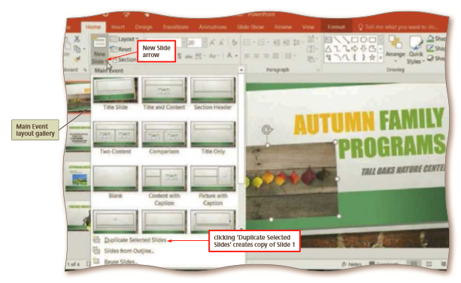
Fig 6-7

Arrange a Slide
The new Slide 2 was inserted directly below Slide 1 because Slide 1 was the selected slide. This duplicate slide needs to display at the end of the presentation directly after the final title and content slide. Why? It is a closing slide that reinforces the concept presented in Slide 1 and indicates to your audiences that your presentation is ending. Changing slide order is an easy process and is best performed in the Slides tab. When you click the thumbnail and begin to drag it to a new location, the remaining thumbnails realign to show the new sequence. When you release, the slide drops into the desired location. Hence, this process of sliding or dragging and then dropping the thumbnail in a new location is called drag and drop. You can use the drag-and-drop method to move any selected item, including text and graphics. The following step moves the new Slide 2 to the end of the presentation so that it becomes a closing slide.

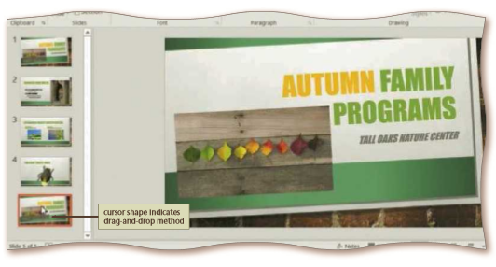
Fig 6-8
Select Slide a Transition
PowerPoint includes a wide variety of visual and sound effects that can be applied to text or content. A slide transition is a special effect used to progress from one slide to the next in a slide show. You can control the speed of the transition effect and add a sound.

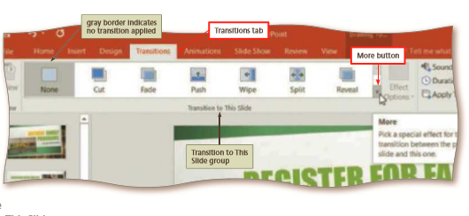
Fig 6-9

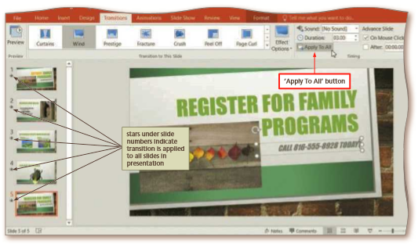
Fig 6-10

