Lab no 11
Object: Microsoft Access for Database
Description:
Microsoft Access allows you to structure and store your information in a set of database tables and can efficiently manage and share large amounts of data. In addition to quickly locating information, the database ensures consistency in the information by linking together the data in different tables. The product allows you to present the data through both professional-looking forms and reports.
If you are moving from Microsoft Office 2003 to Office Professional 2013, then you will notice a big difference in the user interface. Introduced in Office 2007, the ribbon provides a tabbed interface for working in the product. Depending on what you are doing, the ribbon will display additional tool tabs to assist you in a particular task. The database window of Access 2003 has been replaced with a searchable Navigation pane on the left side of the interface that allows you to filter objects of one or more types.
If you are already familiar with Access 2010, then you will find that the desktop database has improved productivity, but the major revision in the product has been the introduction of the Web App.
Access 2013 enables you to create two distinct but related types of databases. The first is a desktop database; this is a database where the components are held in one or more files on your computer or network. The second type of database is called a Web App; this is a new feature in Access and means that the database is stored in Office 365, and the user interface is displayed in a browser window. When developing a Web App, you use a design interface on your computer that is similar to the familiar desktop database interface.
we provide detailed steps so that you can perform activities and at the same time familiarize yourself with how to productively work with the Access desktop database interface.
An Access desktop database contains different types of objects:
▪ Tables Your data is held in a number of tables. The data in most of the tables will be linked to data in other tables. Using this approach of linking or relating data between tables is a key feature of the database and reduces the need to duplicate information.
▪ Queries These bring together the data from one or more tables and present the data either through a datasheet, form, or report. Note that a datasheet is not a separate object, but the interface when displaying data from either a table or query.
▪ Forms These allow more flexibility in presenting data than that allowed in a datasheet. They are the most popular method for viewing and managing data. Of particular note are parent/child forms and subforms, where the subforms display related data from other tables.
▪ Reports Allow you to create a paper-based presentation of your data for printing or previewing on the screen. One unique presentation feature of reports is the ability to have multiple layers of grouping when presenting data.
▪ Macros This is a programming feature for automating operations. Macros can be found in several places in the database; a discussion of macros is beyond the scope of this chapter.
▪ Modules These are used for advanced programming, using the Microsoft Visual Basic for Applications (VBA) programming language common to the other Office products.
This topic is also beyond the scope of this chapter.

Creating a desktop database
Your Access desktop database consists of a single file, which you will create and save on your computer. There are two different methods to get started with a database. You can either choose to create a database by using a predefined template database, or you can start by creating an empty database.
In this exercise, you’ll create a desktop database.
SET UP You don’t need any practice files to complete this exercise, but the MSOffice­
ProBlank.accdb database you create here will be used in further exercises in this chapter. Start Access from the Start screen (Windows 8), or from the Start menu (Windows 7) that is displayed when you click at the left end of the Windows taskbar.
- Click Blank desktop database.
- Enter the file name MSOfficeProBlank.
- Click Create. (fig.11.1)

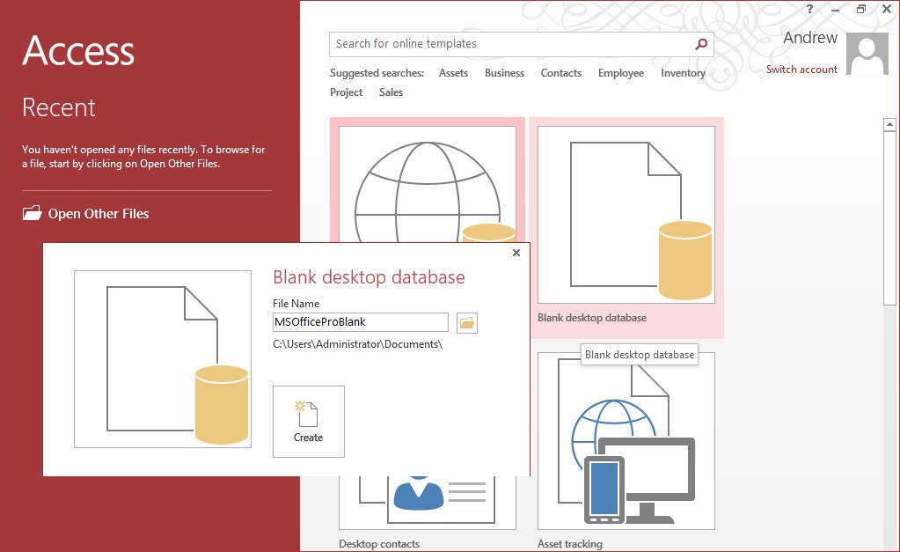
Fig 11.1
TIP When starting Access, you will notice a list of template databases; for example, Asset tracking (Web App) and the templates prefixed with the name Desktop. Desktop asset tracking will create a desktop database. It is worth taking the time to look at a few of these to get some ideas for creating your own applications.
Creating a desktop database
Your database will look similar to the following. Fig 11.2
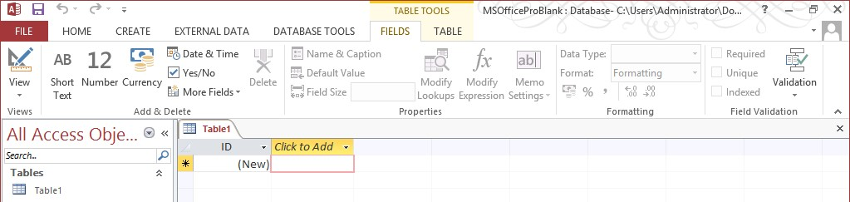
Fig 11.2
When you create a blank database, Access will open to display a new table called Table1. This feature allows you to start using one of several techniques for creating blank tables, which we will look at in the next chapter.
4 Click on the X to close the Table1 object.
The main ribbon will be displayed without any design objects in the database. The Navigation pane displaying All Access Objects is empty. Fig 11.3
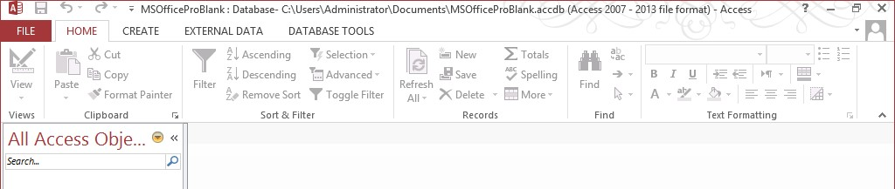
Ribbon tab
Navigation pane
Ribbon icon
Ribbon group
Fig 11.3

CLEAN UP Close the MSOfficeProBlank database. This will close Access.
+

Managing trust locations and macro security
Sooner or later, you will come across the following when opening a database. Fig 11.4
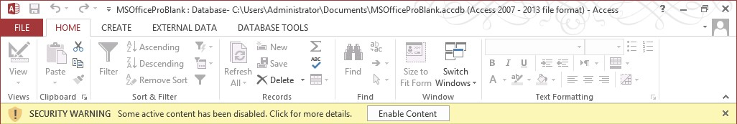
Fig 11.4
Because we live in a world where some people will try and hack or subvert systems, and because Office files can be sent by email from unknown sources, Microsoft, by default, switches off features, and it is up to you to decide what to enable.
If you click the Enable Content button, then the next time that you open the database, you will not need to again answer this question, because you previously enabled content in the file. However, if you use the file system to copy the file, rename the file, or move the file to a different location, then you will again be challenged to enable the content.
There are two aspects of trust that you can manage. The first is the location of a file. Trust locations allow you to establish folders where you can place files that will be trusted. This means that you will not need to enable content for files placed in these folders (this feature can also be switched off, allowing files to be opened from any location). The second aspect of trust is whether the application should be allowed to execute certain macro commands or VBA programming code. Although we will not cover these topics in this book, you should be aware of this capability.
If you are working with your own databases or databases from a trusted source, then managing the trust locations and macro security should not pose a problem. But if you are down loading content from the Internet and macro security is fully enabled and trusted locations disabled, then it is possible that when you open a database, malicious code could be executed without any warning. The final decision is your responsibility, but in this section, we will show you how to enable macros and how you can manage your trusted locations.
In this exercise, you’ll set security parameters for a database. 37
SET UP You need the MSOfficeProBlank.accdb database from the previous exercise to complete this exercise. If you have not already closed the MSOfficeProBlank.accdb database, then close the database and reopen to display the security warning shown at the beginning of this section. If the security warning does not appear, then continue to follow through the exercise, and you should find that your trust settings have already been altered.
- From the File tab, select Options at the bottom of the page.
- Select the Trust Center option.
- Creating a desktop database fig 11.5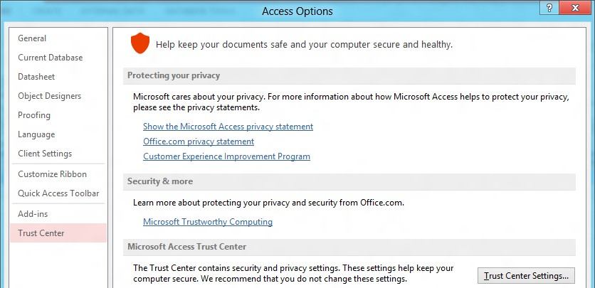 fig 11.5
- Click Trust Center Settings.
- Select Macro Settings and Enable all Macros. Fig 11.6
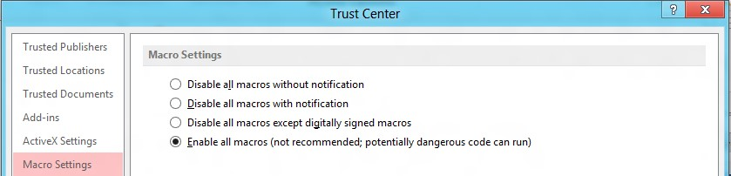
Fig 11.6
- Click Trust Locations.
The next choice is a bit more complicated, because you can either decide to add specific folders where you will trust files, or you can disable the trust locations; trusting files on any location. To enable content at all locations, proceed as follows:
- Click the check box to Disable All trust Locations, or add specific folders to be trusted. Then click OK.
+
Navigating the user interface

Working with the tabs
The second and complementary approach to navigating the Access interface is to use the ribbon. Although you will quickly become familiar with the options on the ribbon to create new objects, after an object has been opened, the ribbon Home tab allows you to quickly change the design of an object.
The File tab is often called the Backstage view—a behind-the-scenes set of choices for configuring Access and performing general operations, such as opening a database or saving a database in a different format. One of the most important menu choices in the Backstage view is the Options choice, because this choice contains a very large number of settings that can be used to control the behavior of the database.
One of the great strengths of Access is that you can do the same thing in more than one way. At first, this may appear confusing, but as you gain familiarity with the product, it is a very useful feature. Access is a powerful development tool. You may find that when you decide to make certain changes in the environment, some paths to features are no longer available. As a simple example, you could choose to hide or fully customize the ribbon, in which case you would then be relying on a right-click to provide you with features that would otherwise associate with the ribbon.
Access has five key ribbon tabs, although, as you open different objects, additional tabs will become available, depending on the context. Following is a list of the tabs and their usage.
▪ File The File tab provides general options and settings for working in the product.
▪ Home This tab is used principally for formatting, filtering, and selecting data while you view the data.
▪ Create This tab is used to create new objects.
▪ External Data This tab is used to import, export, and link to external data.
▪ Database Tools This tab is associated with general operations in maintaining your database.
The File tab has the following features:
▪ Info Allows you to compact and repair your database and encrypt the database with a password.
▪ New Allows you to create a new database.
▪ Open Provides a path to opening recently accessed databases.
▪ Save If you have a design object open, this will save any changes.
▪ Save As This has two functions. If you have an object open, you can save any changes to the object, but more importantly, it allows you to save the database in an alternative format.
▪ Print Allows you to print an object that is open and active.
▪ Close Closes the database.
▪ Account Displays helpful information for connecting to online services.
▪ Options The Access options have been described earlier in this chapter, and are used to configure both the Access installation and database-specific options.

Introduction to Tables
Tables are grids that store information in a database similar to the way an Excel worksheet stores information in a workbook. Access provides several ways to create a table. The default one is by using Datasheet View (see below), but we will use the Design View.fig 11.7
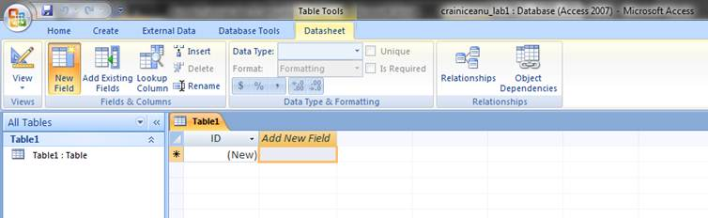
Fig 11.7
Create table in Design view will allow you to create the fields of the table. This is the most common way of creating a table and is explained in detail below.
Create a Table in Design View
Design view allows you to build a table from scratch and set or change every available property for each field. You can also open existing tables in Design view and add, remove, or change fields.
On the View group in the navigation bar, click Design View. You will be prompted to give a name to the table (give a meaningful name) and save it. fig 11.8
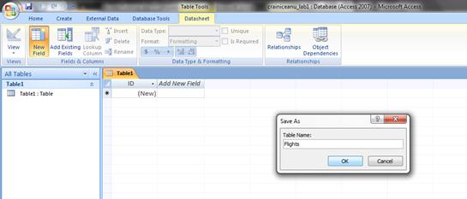fig 11.8
In the Field Name column of the designer, enter the names of your table fields. By default, each new table has a first field called ID that is the primary key for the table. You can delete that field if you want to create your own primary key (right-click and select Delete Rows from the menu) .
In the Data Type column, use the list next to a field name to choose a data type for that field.
Optionally, use the Field Properties pane to set properties for individual fields.
See below for more details:
Design View will allow you to define the fields in the table before adding any data to the datasheet. The window is divided into two parts: a top pane for entering the field name, data type, and an option description of the field, and a bottom pane for specifying field properties. fig 11.9
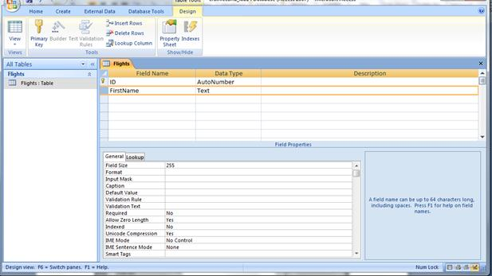
Fig 11.9
Field Name - This is the name of the field and should represent the contents of the field such as "Name", "Address", "Final Grade", etc. The name can not exceed 64 characters in length and may include spaces.
- Data Type is the type of value that will be entered into the fields.
  - Text - The default type, text type allows any combination of letters and numbers up to a maximum of 255 characters per field record.
  - Memo - A text type that stores up to 64,000 characters.
  - Number - Any number can be stored.
  - Date/Time - A date, time, or combination of both.
  - Currency - Monetary values that can be set up to automatically include a dollar sign ($) and correct decimal and comma positions.
  - AutoNumber - When a new record is created, Access will automatically assign a unique integer to the record in this field. From the General options, select Increment if the numbers should be assigned in order or random if any random number should be chosen. Since every record in a datasheet must include at least one field that distinguishes it from all others, this is a useful data type to use if the existing data will not produce such values.
  - Yes/No - Use this option for True/False, Yes/No, On/Off, or other values that must be only one of two.
  - OLE Object - An OLE (Object Linking and Embedding) object is a sound, picture, or other object such as a Word document or Excel spreadsheet that is created in another program. Use this data type to embed an OLE object or link to the object in the database.
  - Hyperlink - A hyperlink will link to an Internet or Intranet site, or another location in the database. The data consists of up to four parts each separated by the pound sign (#): DisplayText#Address#SubAddress#ScreenTip. The Address is the only required part of the string.
- Description (optional) - Enter a brief description of what the contents of the field are.
- Field Properties - Select any pertinent properties for the field from the bottom pane.
Field Properties
Properties for each field are set from the bottom pane of the Design View window.
- Field Size is used to set the number of characters needed in a text or number field. The default field size for the text type is 255 characters. If the records in the field will only have two or three characters, you can change the size of the field to save disk space or prevent entry errors by limiting the number of characters allowed. Likewise, if the field will require more than 255 characters, enter a number up to 255. The field size is set in exact characters for Text type, but options are give for numbers:
  - Byte - Positive integers between 1 and 255
  - Integer - Positive and negative integers between -32,768 and 32,768
  - Long Integer (default) - Larger positive and negative integers between -2 billion and 2 billion.
  - Single - Single-precision floating-point number
  - Double - Double-precision floating-point number
  - Decimal - Allows for Precision and Scale property control
- Format conforms the data in the field to the same format when it is entered into the datasheet. For text and memo fields, this property has two parts that are separated by a semicolon. The first part of the property is used to apply to the field and the second applies to empty fields.
Text and memo format.
Text Format
Format | Datasheet Entry | Display | Explanation
@@@-@@@@ | 1234567 | 123-4567 | @ indicates a required  character or space
@@@-@@@& | 123456 | 123-456 | & indicates an optional  character or space
< | HELLO | Hello | < converts characters to lowercase
> | hello | HELLO | > converts characters to uppercase
@\! | Hello | Hello! | \ adds characters to the end
@;"No Data Entered" | Hello | Hello
@;"No Data Entered" | (blank) | No Data Entered
- Number format. Select one of the preset options from the drop down menu or construct a custom format using symbols explained below:
Number Format
Format | Datasheet Entry | Display | Explanation
###,##0.00 | 123456.78 | 123,456.78 | 0 is a placeholder that displays a digit or 0 if there is none.  # is a placeholder that displays a digit or nothing if there is none.
$###,##0.00 | 0 | $0.00
###.00% | .123 | 12.3% | % multiplies the number by 100 and added a percent sign
- Currency format. This formatting consists of four parts separated by semicolons:
format for positive numbers; format for negative numbers; format for zero values; format for Null values.
Currency Format
Format | Explanation
$##0.00;($##0.00)[Red];$0.00;"none" | Positive values will be normal currency format, negative numbers will be red in parentheses, zero is entered for zero values, and "none" will be written for Null values.
- Date format. In the table below, the value "1/1/01" is entered into the datasheet, and the following values are displayed as a result of the different assigned formats.
Date Format
Format | Display | Explanation
dddd","mmmm d","yyyy | Monday, January 1, 2001 | dddd, mmmm, and yyyy print the full day name, month name, and year
ddd","mmm ". " d", '"yy | Mon, Jan. 1, '01 | ddd, mmm, and yy print the first three day letters, first three month letters, and last two year digits
"Today is " dddd | Today is Monday
h:n:s: AM/PM | 12:00:00 AM | "n" is used for minutes to  avoid confusion with months
- Yes/No fields are displayed as check boxes by default on the datasheet. To change the formatting of these fields, first click the Lookup tab and change the Display Control to a text box. Go back to the General tab choices to make formatting changes. The formatting is designated in three sections separated by semicolons. The first section does not contain anything but the semicolon must be included. The second section specifies formatting for Yes values and the third for No values.
Yes/No Format
Format | Explanation
;"Yes"[green];"No"[red] | Prints "Yes" in green or "No" in red

- Default Value - There may be cases where the value of a field will usually be the same for all records. In this case, a changeable default value can be set to prevent typing the same thing numerous times. Set the Default Value property.
Indexes
Creating indexes allows Access to query and sort records faster. To set an indexed field, select a field that is commonly searched and change the Indexed property to Yes (Duplicates OK) if multiple entries of the same data value are allowed or Yes (No Duplicates) to prevent duplicates.
Validation Rule
Validation Rules specify requirements for the data entered in the worksheet. Examples of field validation rules include:
<> 0 to not allow zero values,
>= 0 to only allow numbers that are greater or equal to 0
="A" or = "B" to only allow value A or value B
??? to allow only all data strings three characters in length, etc.
You can click the expression builder ("...") button at the end of the Validation Rule box to write the validation rule.
Validation Text
A customized message can be displayed to the user when data that violates the rule setting is entered, so the user knows how to correct the errors.
Input Masks
An input mask controls the value of a record and sets it in a specific format. They are similar to the Format property, but instead display the format on the datasheet before the data is entered. For example, a telephone number field can formatted with an input mask to accept ten digits that are automatically formatted as "(555) 123-4567". The blank field would look like (___) ___-____. An an input mask to a field by following these steps:
- In design view, place the cursor in the field that the input mask will be applied to.
- Click in the white space following Input Mask under the General tab.
- Click the "..." button to use the wizard or enter the mask, (@@@) @@@-@@@@, into the field provided. The following symbols can be used to create an input mask from scratch:
Input Mask Symbols
Symbol | Explanation
A | Letter or digit
0 | A digit 0 through 9 without a + or - sign and with blanks displayed as zeros
9 | Same as 0 with blanks displayed as spaces
# | Same as 9 with +/- signs
? | Letter
L | Letter A through Z
C or & | Character or space
< | Convert letters to lower case
> | Convert letters to upper case
Primary Key
Every record in a table must have a primary key that differentiates it from every other record in the table. In some cases, it is only necessary to designate an existing field as the primary key if you are certain that every record in the table will have a different value for that particular field. A social security number is an example of a record whose values will only appear once in a database table.
Designate the primary key field by right-clicking on the record (or records) and selecting Primary Key from the shortcut menu or select Edit|Primary Key from the menu bar. The primary key field will be noted with a key image to the left. To remove a primary key, repeat one of these steps.
If none of the existing fields in the table will produce unique values for every record, a separate field must be added. Access will prompt you to create this type of field at the beginning of the table the first time you save the table and a primary key field has not been assigned. The field is named "ID" and the data type is "autonumber". Since this extra field serves no purpose to you as the user, the autonumber type automatically updates whenever a record is added so there is no extra work on your part.
Adding Records
Add new records to the table in datasheet view by typing in the record beside the asterisk (*) that marks the new record. You can also click the new record button at the bottom of the datasheet to skip to the last empty record.
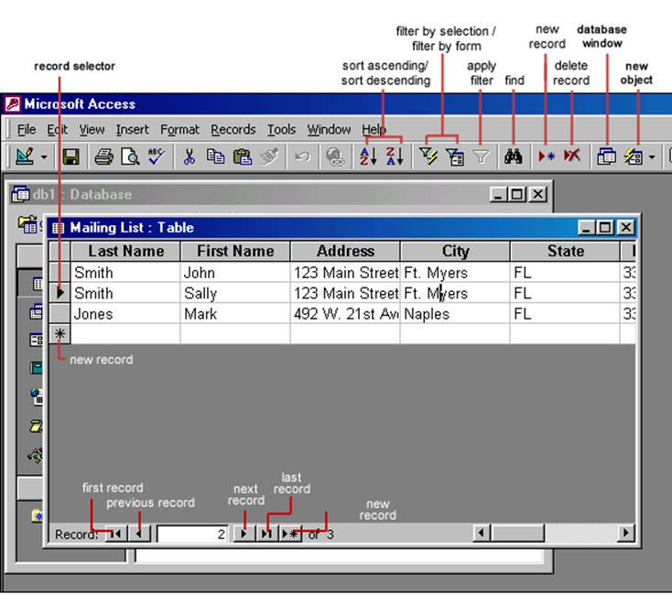
Editing Records
To edit records, simply place the cursor in the record that is to be edited and make the necessary changes. Use the arrow keys to move through the record grid. The previous, next, first, and last record buttons at the bottom of the datasheet are helpful in maneuvering through the datasheet.
Deleting Records
Delete a record on a datasheet by placing the cursor in any field of the record row and select Edit|Delete Record from the menu bar or click the Delete Record button on the datasheet toolbar.
Adding and Deleting Columns
Although it is best to add new fields (displayed as columns in the datasheet) in design view because more options are available, they can also be quickly added in datasheet view. Highlight the column that the new column should appear to the left of by clicking its label at the top of the datasheet and select Insert|Column from the menu bar. Entire columns can be deleted by placing the cursor in the column and selecting Edit|Delete Column from the menu bar.

Exercise

Create your own database using all parameters learn in this lab

